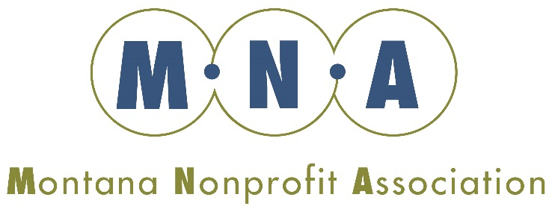

2018-2019 Board Officers and Committees

Chair: C.B. Pearson
Vice-Chair: Jason Rittal
Secretary: Susan Denson Guy
Treasurer: Sherm Weimer

Executive Committee
(Chartered)
C. B. Pearson, (chair)*
Jason Rittal
Susan Denson-Guy
Sherm Weimer
Leslie Modrow**
Andrea Vernon**
Larry Johnson **

Governance and Nominating (Chartered)
Leslie Modrow (chair)
Dee Incoronato
Larry Johnson
Susan Denson Guy

Finance and Audit
(Chartered)
Sherm Weimer (chair)
Alison Paul
Dawn Wrigg
Jason Rittal

*Ex Officio member of all committees
**Nonvoting members of Executive Committee
***Current MNA Board Member

Public Policy Council
(Advisory to Board)
Andrea Vernon (Chair)***
Aidan Myhre
Alison Paul***
Andrea Davis
Bob Wilmouth***
CB Pearson***
Dee Incoronato***
Ed Eck
Geoff Birnbaum
Jason Rittal***
Jim Bennett ***
Jim Soft
Judy Held
Laura Hoehn
Mary Hernandez
Mitch Tropila
Ned Cooney
Paul Tuss
Rob Tallon***
Sheila Rice
Susan Denson-Guy***

Resource Development Council
(Advisory to Board)
Larry Johnson (chair)***
Leslie Modrow***
Rob Tallon***
Ned Cooney
Judy Held
Peggy Owens

